Party Game

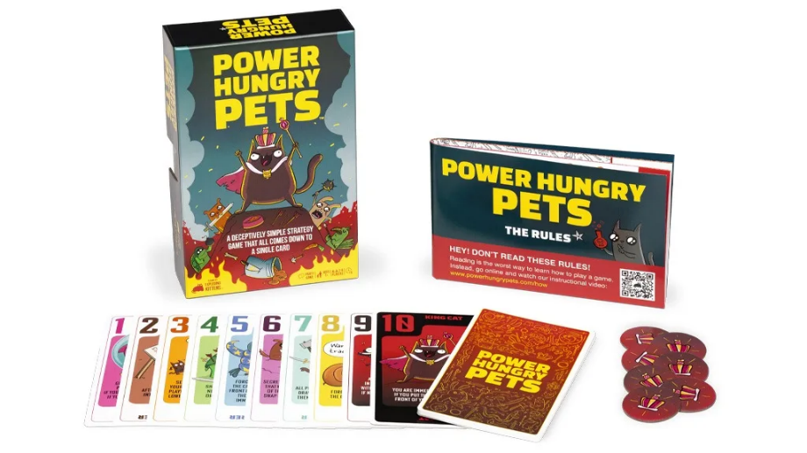

power hungry pets

Number of players: 2-6

age: 7 years old or older

playing time: 15 minutes

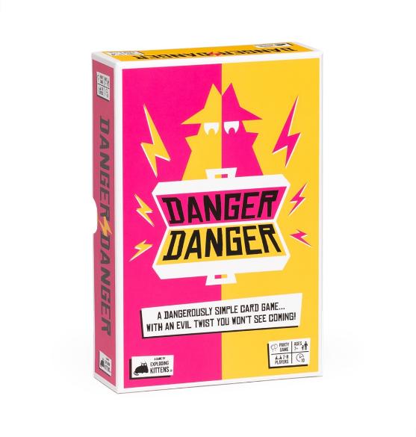

Danger Danger

Number of players: 2-8

age: 7 years old or older

playing time: 10 minutes

Mind Up

Number of players: 3-6

age: 8 years old or older

playing time: 15-20 minutes

Long Shot the Dice Game

Number of players: 1-8

age: 14 years old or older

playing time: 25 minutes

Family Game

Food Fighters

Number of players: 2

age: 8 years old or older

playing time: 20-30 minutes

Exploding Kittens

Number of players: 2-5

age: 7 years old or older

playing time: 15 minutes

That’s Not a Hat

Number of players: 3-8

age: 8 years old or older

playing time: 15 minutes

Codenames: Marvel Edition

Number of players: 2-8

age: 8 years old or older

playing time: 15 minutes

Love Letter

Number of players: 2-6

age: 10 years old or older

playing time: 20 minutes

strategy game

Intrepid: Deluxe

Number of players: 1-4

age: 13 years old or older

playing time: 90 minutes

Rats of Wistar

Number of players: 1-4

age: 13 years old or older

playing time: 90 minutes

The White Castle

Number of players: 1-4

age: 12 years old or older

playing time: 80 minutes

Nucleum

Number of players: 1-4

age: 14 years old or older

playing time: 60-150 minutes

Coimbra

Number of players: 2-4

age: 14 years old or older

playing time: 60-90 minutes

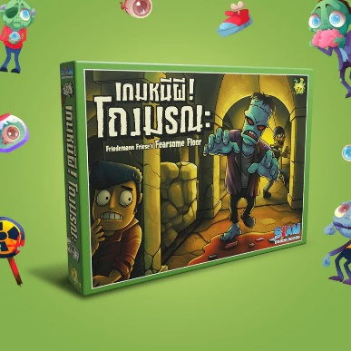**Family**

Fearsome Floor

Price 1,350 baht

2-7 players

Age 10+

Playing time 60 min

The storyline in Friedemann Friese's Fearsome Floors (aka, Finstere Flure) continues the FFF-saga from Friese's earlier game, with players trying to escape from Fürst Fieso. Story aside, what we have is a wonderful race game in which the players must move through a dungeon as quickly as possible – or at least within 14 turns – before it crumbles over their heads.

Players could reach the exit in only seven turns if everything were peaceful and quiet, but unfortunately the dungeon is also the home of a very hungry monster! Each round, players take turns moving one disk at a time, flipping over the disk after moving it to reveal the movement points available for the next round. They can try to lead the monster, who is always after fresh prey, to opponents' pieces, but they may find themselves eaten instead! Pieces can slide along blood slicks or might be crushed between a boulder and a wall. You can even try to get the monster to teleport to another part of the board, where it will fall upon its next victim!

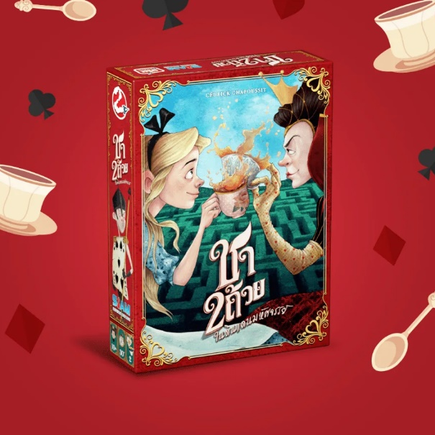tea for 2

Price 850 baht

2 players

Age 10+

Playing time 20-30 min

Tea for 2 is an easy-to-learn, yet hard to master deck-building game set in Alice's Wonderland that combines easy rules and strategic play. To do battle, players simultaneously flip over the top card of their decks. The player with the highest card can use the card's effect or buy a new card for their deck! Players will collect hourglasses and tarts, and try to keep their hands on the pink flamingo to win!

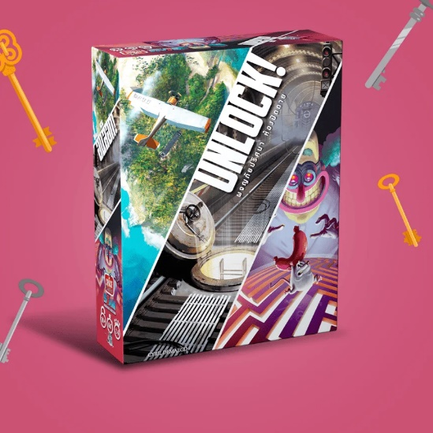**Unlock!**

**Price 1,100 baht**

2-6 players

Age 10+

Playing time 45-75 min

Family / Startegy

Unlock! is a cooperative card game inspired by escape rooms that uses a simple system which allows you to search scenes, combine objects, and solve riddles. Play Unlock! to embark on great adventures, while seated at a table using only cards and a companion app that can provide clues, check codes, monitor time remaining, etc.

Unlock! Escape Adventures includes three separate scenarios for you to explore:

In The Formula, you enter a secret laboratory to recover a mysterious serum that has been developed by a scientist. Will you solve all the riddles and get out in less than an hour?

In Squeek & Sausage, you need to thwart the plans of the despicable Professor Noside!

In The Island of Doctor Goorse, you must visit the island of an eccentric antique collector billionaire and overcome its traps!

An included ten-card tutorial allows you to learn how to play without reading the game rules.

Use the link below in order to download the Tutorial and a demonstration scenario, both in print-and-play!

Note: Unlock! requires a free application to be downloaded from the App Store or Google Play. Once downloaded, an internet connection is not required during game play.

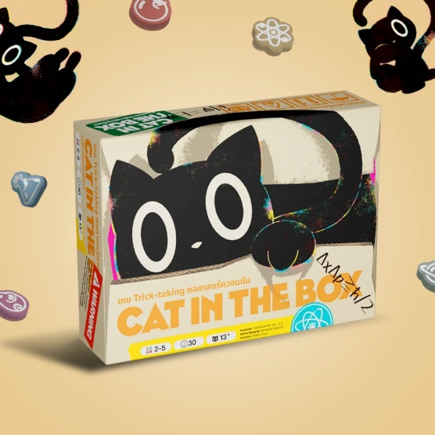**Unlock!**

**Price 1,100 baht**

2-5 players

Age 13+

Playing time 20-40 min

Family

Cat in the Box: Deluxe Edition is the quintessential quantum trick-taking card game for 2 - 5 cool cats, where your card’s color isn’t defined until you play it! Hypothesize how many tricks you will win, and record your bid. Place tokens on the community research board as you play your hand, and connect large groups of tokens to score even more points. Plan your tricks carefully as you cannot claim the color of a card with the same number that has already been declared. Doing so would be pawsitively catastrophic as you have just created a paradox!

New Deluxe Edition features:

Supports 2-5 players

High quality geekbits-style plastic tokens

Recessed player boards

Recessed Center Research board

Score pad

And a custom plastic insert to keep Cat in the Box: Deluxe Edition tidy!

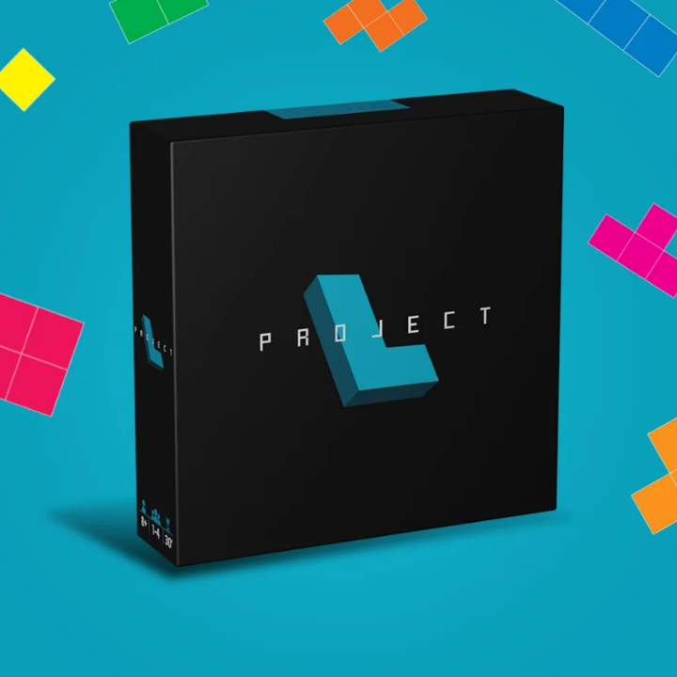**Project L**

**Price 1,400 baht**

1-4 players

Age 8+

Playing time 20-40 min

Family

Build pieces, develop an engine, perfect your strategy, and win the game!

Project L is a fast-paced, tile-matching brain burner with triple-layer 3D puzzles and lovely acrylic pieces. Challenge your friends to a game of simple design but intricate gameplay that makes a lasting impression!

The core of the game lies in using your pieces to complete puzzles. Starting with just two basic pieces, you use three actions every turn to develop a powerful engine. With more pieces of various types, you can efficiently complete even the most difficult puzzles. The puzzles you complete award you points or new pieces to further fuel your engine. Can you outsmart your opponents?

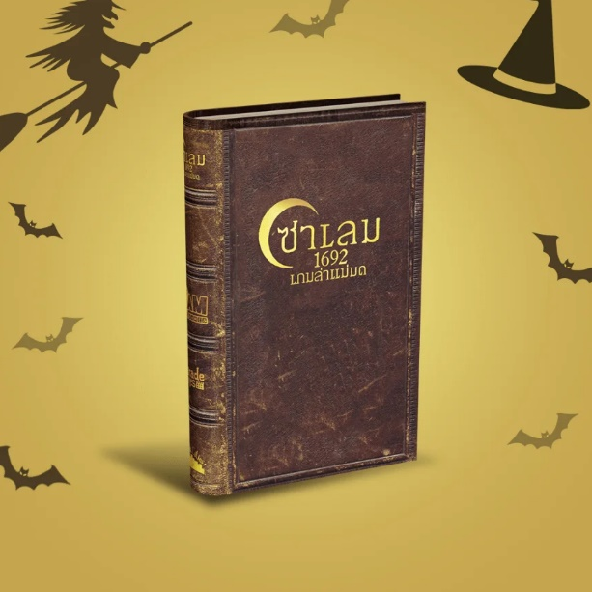**Salem 1692**

**Price 950 baht**

4-12 players

Age 12+

Playing time 25-35 min

Party

Accuse and defend your fellow townsfolk as you hunt down the witches of Salem. Act fast, before conspiracy turns you against your own.

The game is packaged in a faux book box that closes magnetically. The game, disguised as a worn out leather book, can easily hide on your bookshelf and masquerade as an antique.

Players can play as prominent villagers from the old Salem town, and even read their bios in the instruction manual. The servant girl Mary Warren, pastor Samuel Parris, farmer John Proctor, storyteller Tituba, and beggar Sarah Good are some of the 12 characters featured in the game.

Players, each acting as one of these unique characters, are given 3-5 Tryal cards (depending on the number of players). These Tryal cards reveal the true identity of each player, "Witch" or "Not a Witch."

During gameplay, players gather cards that they use to accuse, or defend, other players. Deciding who to trust is key to survival, since you can never play a card on yourself. When you suspect someone to be a witch, you can begin accusing them with red accusation cards. When enough accusations have been placed on one of the players, the player who lays the final accusation chooses one of that player's Tryal cards to reveal. Once all "Witch" Tryal cards have been found, the villagers of Salem win.

Players can also use green and blue cards such as "Alibi", "Stocks", "Matchmaker", "Asylum", and "Scapegoat" to help or hurt their allies or enemies.

As players draw cards, they will eventually draw black cards that take immediate effect. One black card, "Night", forces all players to close their eyes while the Witches choose someone to eliminate and the Constable chooses someone to potentially save. The other black card, "Conspiracy," forces all players to take a face-down Tryal card from the player to their left. Killing witches quickly is essential, otherwise "Conspiracy" may soon have the whole town turned evil.

Before long, accusations will be flying, and screams of "She's a WITCH!" will wake the neighbours. Will you be the hero who purges your town of witches, or will you be wrongly accused and hung for witchcraft? Or perhaps you will be a witch yourself, escape conviction, and bring Salem to the ground.

Volume 1 in the Dark Cities Series by Facade Games.

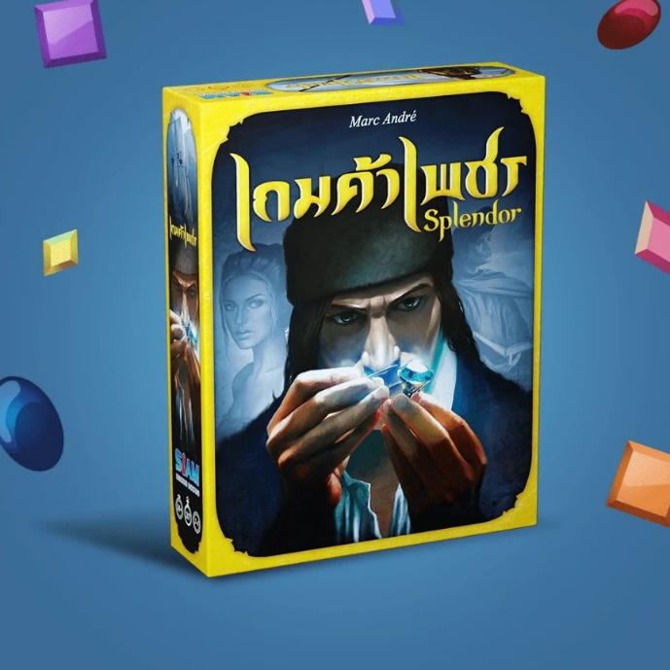**Splendor**

**Price 1,500 baht**

2-4 players

Age 10+

Playing time 30 min

family

Splendor is a game of chip-collecting and card development. Players are merchants of the Renaissance trying to buy gem mines, means of transportation, shops—all in order to acquire the most prestige points. If you're wealthy enough, you might even receive a visit from a noble at some point, which of course will further increase your prestige.

On your turn, you may (1) collect chips (gems), or (2) buy and build a card, or (3) reserve one card. If you collect chips, you take either three different kinds of chips or two chips of the same kind. If you buy a card, you pay its price in chips and add it to your playing area. To reserve a card—in order to make sure you get it, or, why not, your opponents don't get it—you place it in front of you face down for later building; this costs you a round, but you also get gold in the form of a joker chip, which you can use as any gem.

All of the cards you buy increase your wealth as they give you a permanent gem bonus for later buys; some of the cards also give you prestige points. In order to win the game, you must reach 15 prestige points before your opponents do.

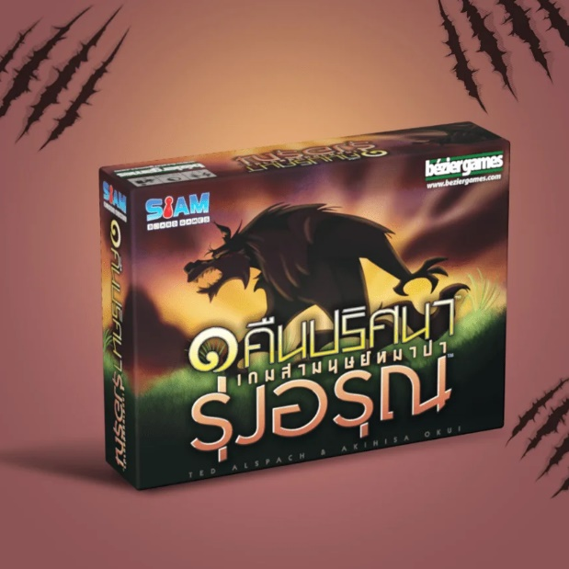**One night daybreak**

**Price 850 baht**

3-7 players

Age 8+

Playing time 10 min

Party

One Night Ultimate Werewolf Daybreak is a fast game for 3-7 players in which everyone gets a hidden role, each with a special ability. (No plain "villagers" here!) In the course of a single morning, your village will decide who among them is a werewolf...because all it takes is finding one werewolf to win!

Daybreak includes eleven new roles, and it can be played on its own or combined with the original One Night Ultimate Werewolf game; when combined, you can have up to ten players in a single game.

**Bubbly**

**Price 450 baht**

2-4 players

Age 6+

Playing time 15 min

Family

The life of a soap bubble is not easy. Small and brave, it tries to fly as long as possible, fighting against the elements that surround it.

In Bubbly, you take turns playing as a soap bubble. As a bubble, your goal is to stay in the air as long as possible. Meanwhile, your opponents have no goal other than to knock you down. To do this, they play cards to create a path. You have to manage your hand as best you can to keep moving forward, at the risk of falling dangerously close to the ground. To go up or straight, you need to play a matching card; to descend, you can play any color.

The bubble that goes the furthest is declared the winner! Bluff your opponents to avoid showing your weaknesses and fly to victory.

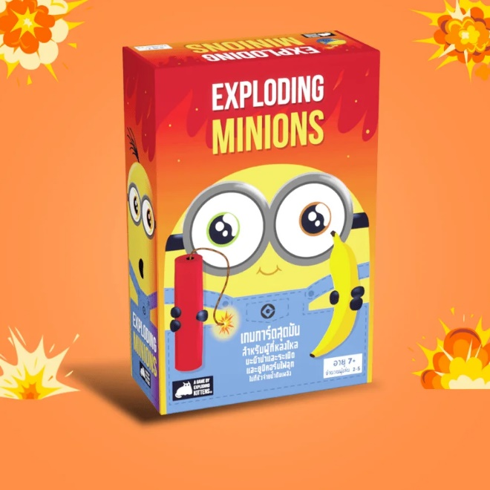

**Exploding Minions**

**Price 950 baht**

2-5 players

Age 7+

Playing time 15 min

Party

Introducing: Exploding Minions! Play the all new Minions themed version of your favorite explosive card game featuring new card types and magical bananas.

Exploding Minions is a Minions-powered version of Russian Roulette. Players take turns drawing cards until someone draws an Exploding Minion and loses the game. The deck is made up of cards that let you avoid exploding by peeking at cards before you draw, forcing your opponent to draw multiple cards, or shuffling the deck.

The game gets more and more intense with each card you draw because fewer cards left in the deck means a greater chance of drawing the Exploding Minion.

The Minions bring a new game-changing card with them that allows players to Clone cards.

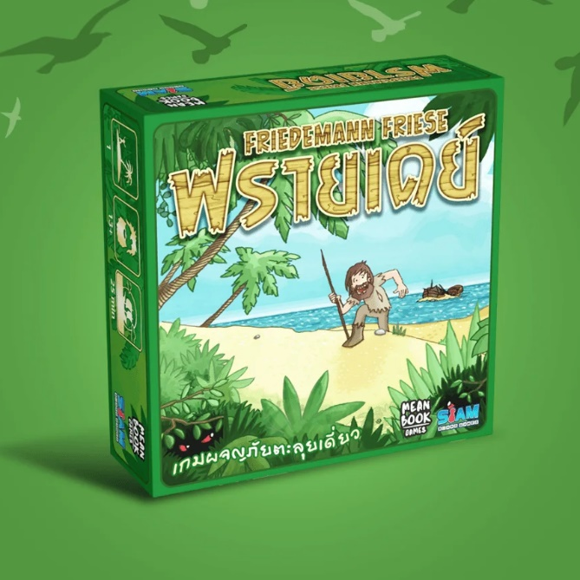**Friday**

**Price 790 baht**

1 players

Age 13+

Playing time 25 min

Strategy

Friday, the second game in the Friedemann Friese Series: Freitag-Project (Friedemann Friese), is based on the story of Robinson Crusoe and his loyal partner Friday (Freitag). You play as Friday, and when Robinson Crusoe crashes his ship on your island, your peaceful times are disturbed. You must help Robinson to survive the island and prepare him to defeat the pirates that are coming for the island.

Friday is a solitaire deck-building game in which you optimize your deck of fight cards in order to defeat the hazards of the island. During a turn the player will attempt to defeat hazard cards by playing fight cards from their deck. If defeated, a hazard card will become a fight card and is added to the player's deck. If failed, the player will lose life points but also get the opportunity to remove unwanted cards from their fight deck. In the end, the player will use their optimized fight deck to defeat the two pirate ships coming for the island, allowing Robinson Crusoe to escape the island and allowing you to finally have your peace back!

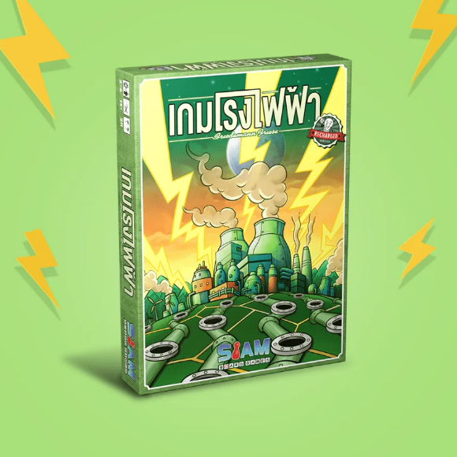

**Power Grid Recharged**

**Price 1,700 baht**

2-6 players

Age 12+

Playing time 120 min

strategy

Power Grid is the updated release of the Friedemann Friese crayon game Funkenschlag. It removes the crayon aspect from network building in the original edition, while retaining the fluctuating commodities market like Crude: The Oil Game and an auction round intensity reminiscent of The Princes of Florence.

The objective of Power Grid is to supply the most cities with power when someone's network gains a predetermined size. In this new edition, players mark pre-existing routes between cities for connection, and then bid against each other to purchase the power plants that they use to power their cities.

However, as plants are purchased, newer, more efficient plants become available, so by merely purchasing, you're potentially allowing others access to superior equipment.

Additionally, players must acquire the raw materials (coal, oil, garbage, and uranium) needed to power said plants (except for the 'renewable' windfarm/ solar plants, which require no fuel), making it a constant struggle to upgrade your plants for maximum efficiency while still retaining enough wealth to quickly expand your network to get the cheapest routes.

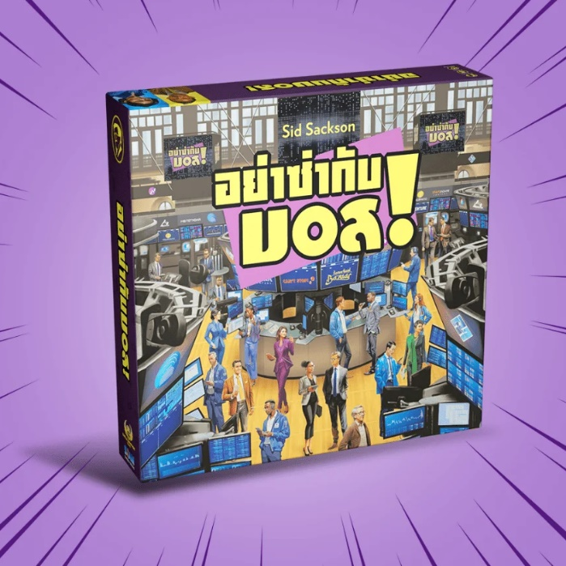**I’m the boss**

**Price 2,250 baht**

3-6 players

Age 12+

Playing time 60+ min

Family / strategy

The six Investor cards are shuffled and one is dealt face up to each player. Any Investor cards not dealt to the players are set aside for now. The Influence Card deck is shuffled and each player is dealt five cards face down. The player whose Investor is first in alphabetical order goes first. The player to the starting player’s right places the Dollar marker on any space on the game board.

Each space on the game board represents a potential deal which Investors have to approve the deal and the number of dividends to be paid to those investors.

On one’s turn, a player can open negotiations on the deal where the Dollar marker rests or roll the six-sided die. If the player rolls the die, the Dollar marker is advanced clockwise around the game board counting the available deals as spaces. Once the Dollar marker rests, the player may try to negotiate that deal or draw three Influence cards. If by drawing cards, the player’s hand exceeds twelve the player chooses which cards to discard to the limit.

Should a player choose to make the deal, the player negotiates with the player or players representing the Investors how to divide the money at stake. The amount is number of dividends written on the space multiplied by value of the shares written on the deal tile. Any or all of the players may use their Influence cards to affect the outcome of the deal:

• Clan cards may act in place of Investors whether the Investors are in play or not.

• Travel cards put Investors out of play for the negotiations. Some are specific for a given Investor; some are wild to be played on any Investor.

• Recruitment cards can only be played in sets of three to steal another player’s Investor and make it your own.

• Boss cards give the player control of the negotiations.

• Stop cards immediately stop the effects of Travel, Recruitment, and Boss Influence cards.

The players are paid from the bank when a deal has been struck. The game board space is covered with the Deal tile (effectively closing the space from further game play), the Dollar marker is moved to the next open space, and play continues with next player.

Once nine deals have been made, a die is rolled after each subsequent deal to determine whether the game ends (with the odds increasing each time). Victory goes to whoever has the biggest bankroll!

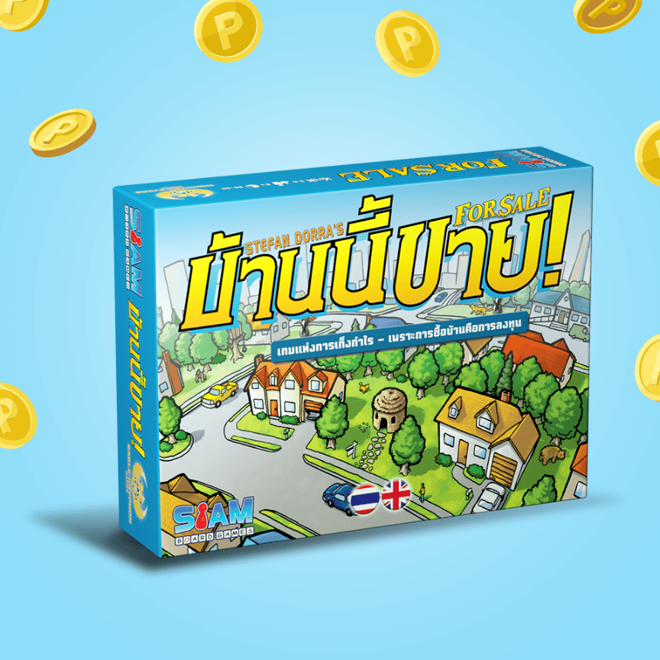**For sale**

**Price 950 baht**

3-6 players

Age 8+

Playing time 20-30 min

Family

For Sale is a quick, fun game nominally about buying and selling real estate. During the game's two distinct phases, players first bid for several buildings then, after all buildings have been bought, sell the buildings for the greatest profit possible.

The original Ravensburger/FX Schmid edition (1997/98) has slightly different rules than later English editions, and only 20 buildings instead of 30.

The Überplay 2005 Edition has new art, rules and card distribution changes, and it accommodates 3-6 players.

The Gryphon 2009 Edition uses the Überplay art for the faces of the property cards, while replacing most other art. The rules are the same as the Überplay edition, with the exception of the rounding rule (which was stated in different ways in different printings of the Überplay edition).

Rounding rule

The rounding rule preferred by the designer Stefan Dorra is that players get back half of their bid rounded DOWN (not UP), as confirmed in correspondence with him here and here. A history of how the rounding rule has changed in different editions is documented here.